import pandas as pd
import numpy as np
import matplotlib.pyplot as plt
import scipy.stats as stats
import seaborn as sns
import statsmodels.api as smf
import warnings
warnings.filterwarnings('ignore')

Look at the data given below. Plot the data, find the outliers and find out μ,σ,σ^2
Name of company Measure X
Allied Signal 24.23%
Bankers Trust 25.53%
General Mills 25.41%
ITT Industries 24.14%
J.P.Morgan & Co. 29.62%
Lehman Brothers 28.25%
Marriott 25.81%
MCI 24.39%
Merrill Lynch 40.26%
Microsoft 32.95%
Morgan Stanley 91.36%
Sun Microsystems 25.99%
Travelers 39.42%
US Airways 26.71%
Warner-Lambert 35.00%\

measure_x = [24.23,25.53,25.41,24.14,29.62,28.25,25.81,24.39,40.26,32.95,91.36,25.99,39.42,26.71,35.00]
name_of_company = ['Allied Signal','Bankers Trust','General Mills','ITT Industries','J.P.Morgan & Co.','Lehman Brothers',
'Marriott','MCI','Merrill Lynch','Microsoft','Morgan Stanley','Sun Microsystems','Travelers','US Airways',
'Warner-Lambert']
plt.figure(figsize = (8,8))
plt.pie(measure_x, labels = name_of_company, autopct= '%.2f%%',shadow = True,
explode = [0.0,0.0,0.0,0.0,0.0,0.0,0.0,0.0,0.0,0.0,0.1,0.0,0.0,0.0,0.0],
textprops = {'size':'medium',
'fontweight':'bold',
'color':'black'})
plt.title('Name of Companies with respect to X', fontsize = 18, fontweight = 'bold', color='b')
plt.savefig('Question1piechart.png')
plt.show()
plt.figure(figsize = (10,9))
ax = sns.barplot(y = measure_x, x = name_of_company, edgecolor='black')
plt.xticks(rotation = 90, fontsize = 12, fontweight = 'bold')
for i in ax.containers:
ax.bar_label(i,)
plt.show()
sns.boxplot(measure_x)
plt.savefig('question1boxplot.png')
plt.show()
measure_x=pd.Series(measure_x)
Q1 = np.quantile(measure_x,0.25)
Q3 = np.quantile(measure_x,0.75)
med = np.median(measure_x)
IQR = Q3 - Q1
upper_bound = Q3+(1.5*IQR)
lower_bound = Q1-(1.5*IQR)
print('First Quantile=', Q1, 'Second Quantile=', med, 'Third Quantile=', Q3,
'Inter-Quartile Range=', IQR, 'Upper Whisker=', upper_bound, 'Lower Whisker=', lower_bound)
Outliers = measure_x[(measure_x <= lower_bound) | (measure_x >= upper_bound)]
print('The outlier in the boxplot:',Outliers)
Outliers = measure_x[(measure_x >= upper_bound)]
print('The outlier in the boxplot:',Outliers)
print(measure_x.describe())
print("Variance=",measure_x.var())

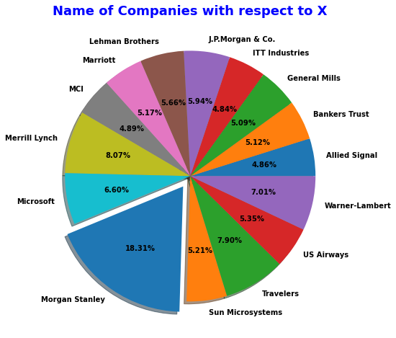

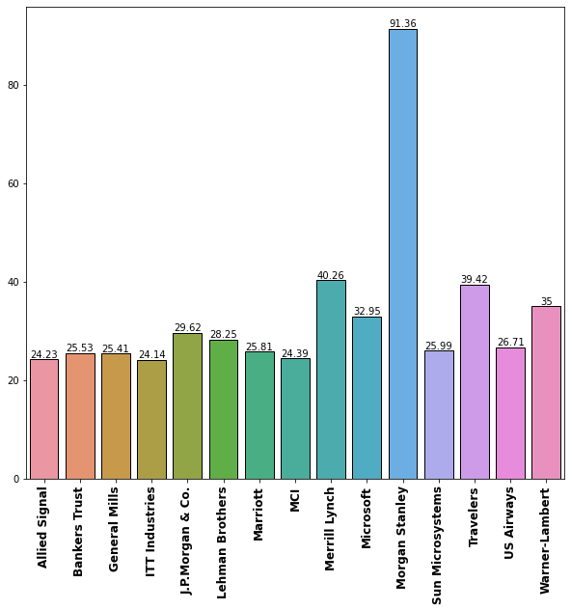
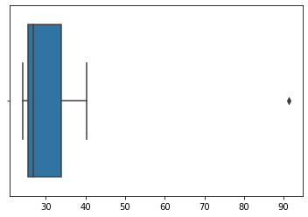

First Quantile= 25.47 Second Quantile= 26.71 Third Quantile= 33.975 Inter-Quartile Range= 8.505000000000003 Upper Whisker= 46.7325 Lower Whisker= 12.712499999999995
The outlier in the boxplot: 10 91.36
dtype: float64
The outlier in the boxplot: 10 91.36
dtype: float64
count 15.000000
mean 33.271333
std 16.945401
min 24.140000
25% 25.470000
50% 26.710000
75% 33.975000
max 91.360000
dtype: float64
Variance= 287.1466123809524

